# **PERSONAL MEDICAL ASSISSTANCE**

NAME: PRADEEP RAJA MOHAN

Description:

I developed an end to product in core Java using OOP concept of development and used MySql as my database. Modelled database in such a way to store data and retrieve it back efficiently. To maintain proper code reusability and making decoupling of major components from each other I Implemented the complete project following MVC Arcitecture.

It is personal medical application which is used to keep track of the medicine which are prescribed by the doctor to a patient and patient can view the prescription given by the doctor. XML Parsers (DOM and SAX) are created to load the data to MySQL Database from XML.

SCREEN SHOTS:

1. login screen

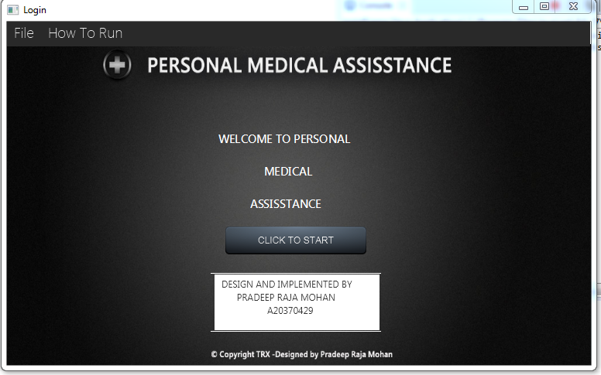

1. How to run

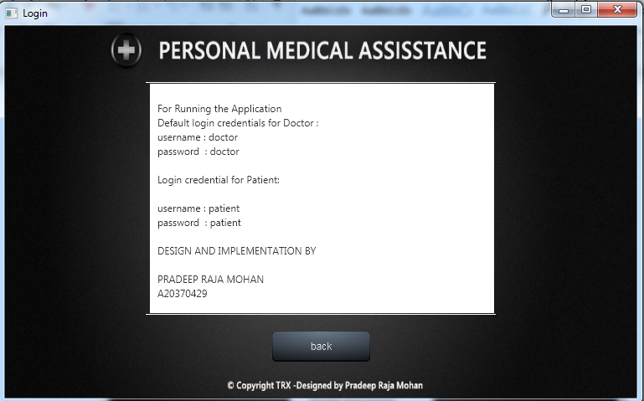

1. Login screen

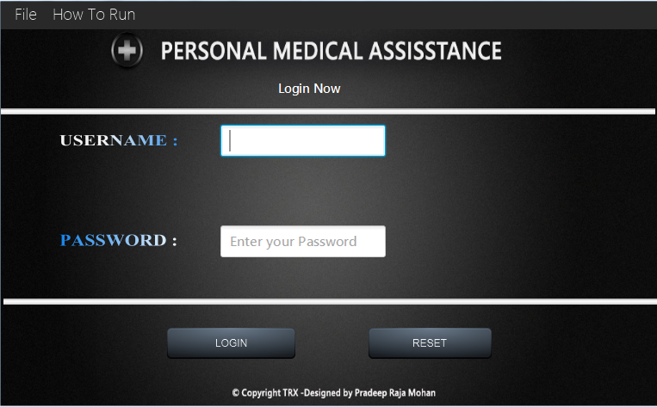

1. doctor portal

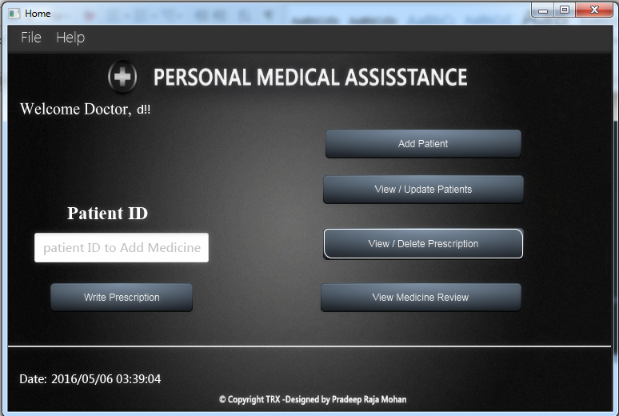

1. Add patient

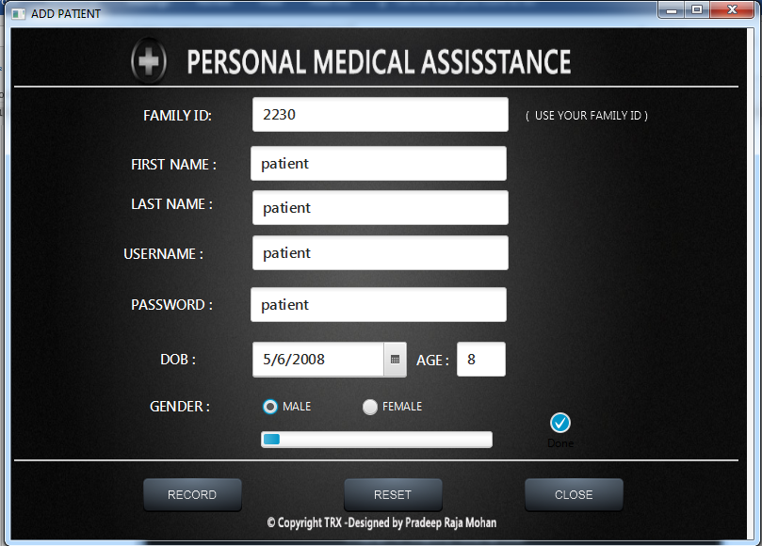

1. Record Added

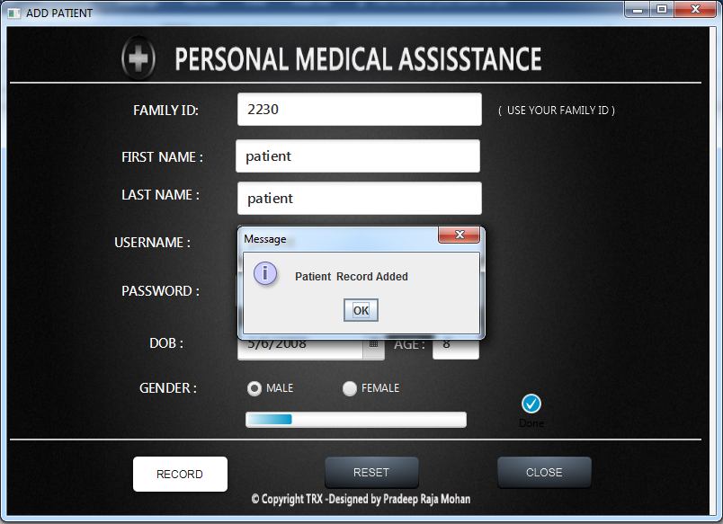

1. view Patients

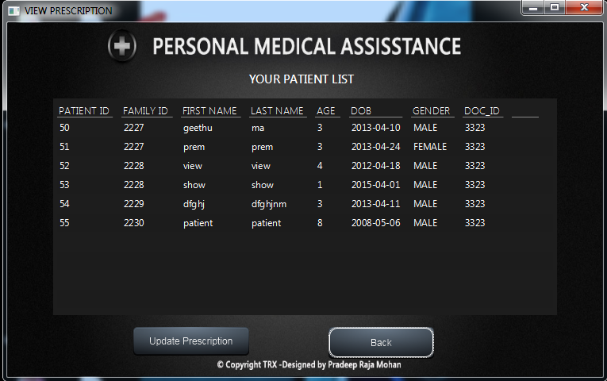

1. update prescription from table

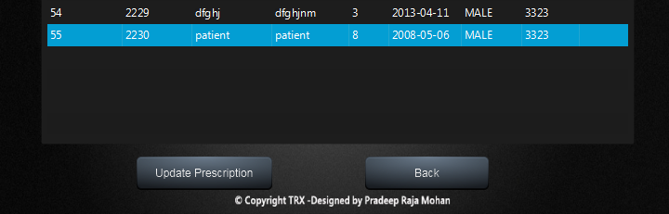

1. prescription update

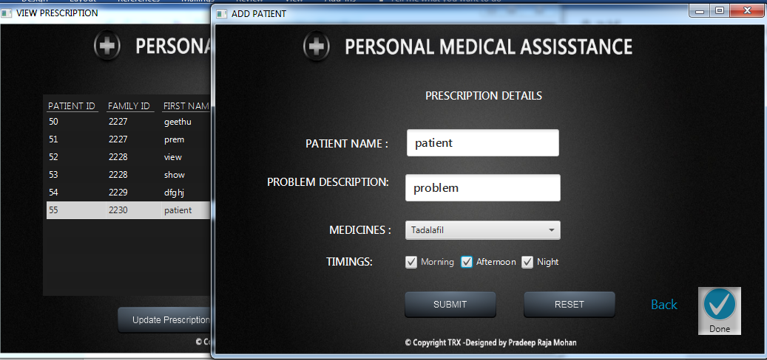

1. view prescription

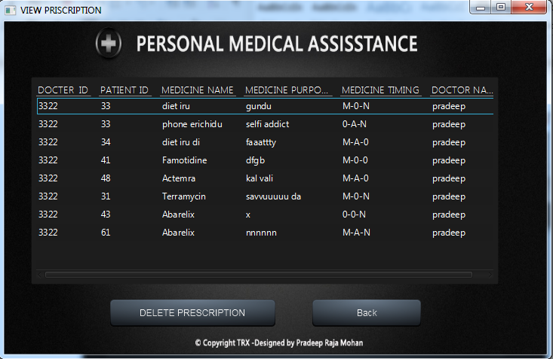

1. view Medicine Review

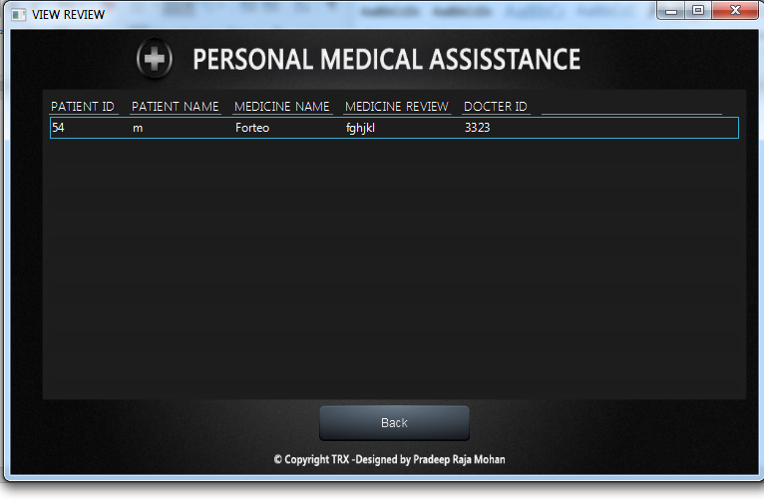

1. write prescription – enter patient ID

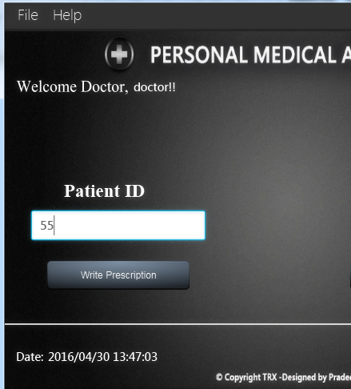

displaying details of the patient

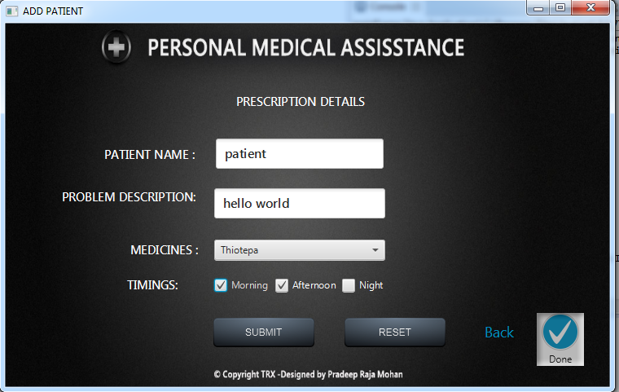

1. patient login

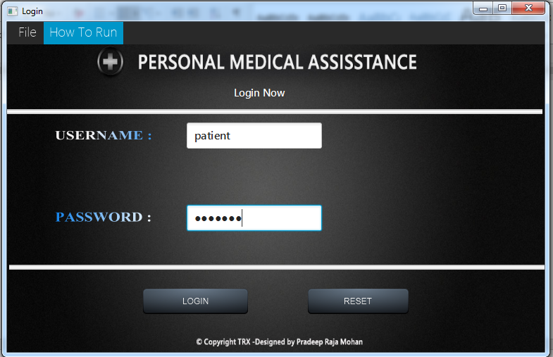

1. Patient Interface

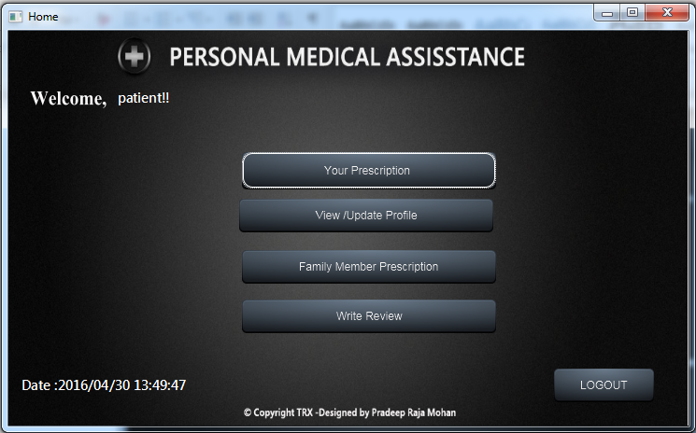

1. View your Prescription

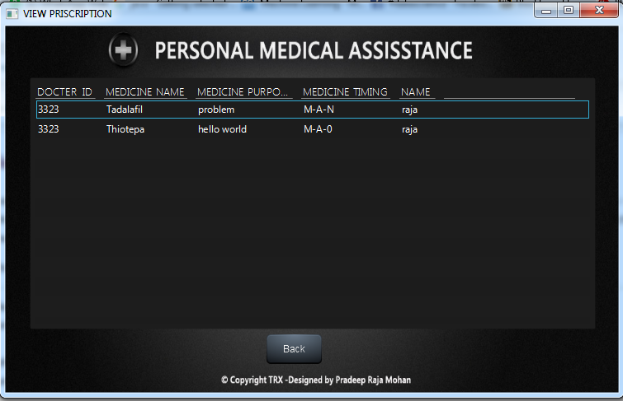

1. view update profile

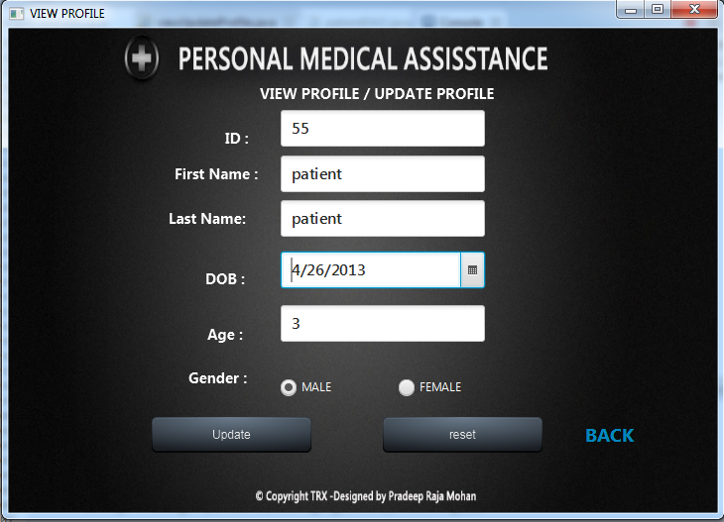

1. update done

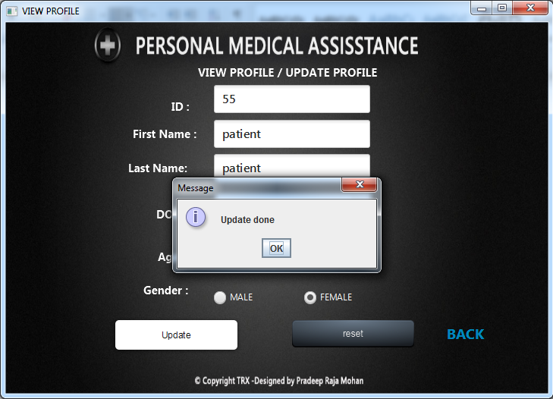

1. view Family Prescription

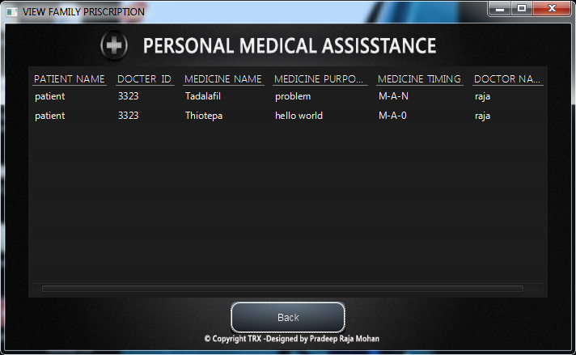

1. Write review

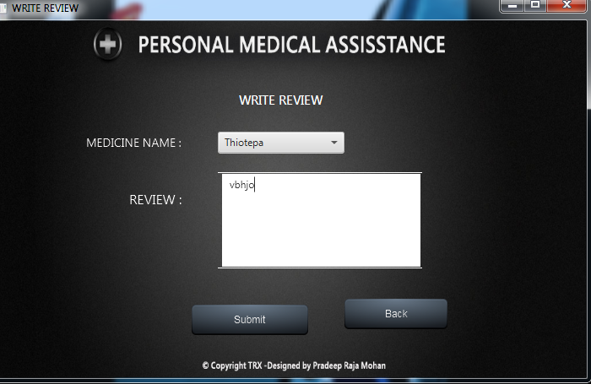

VALIDATIONS :

1. username and password validation

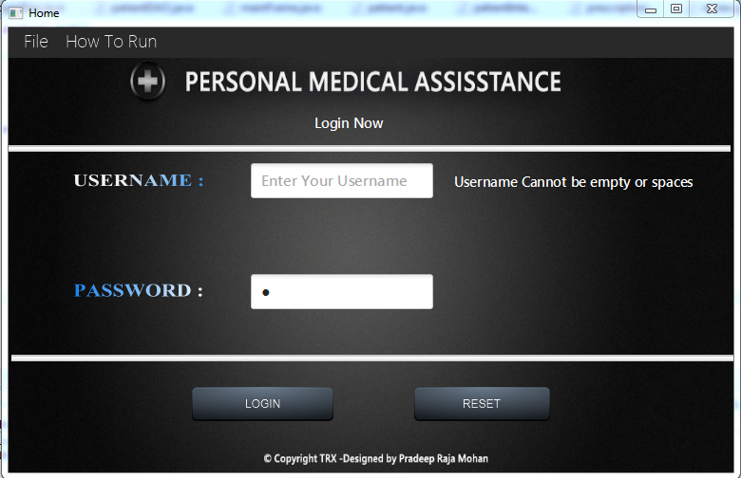

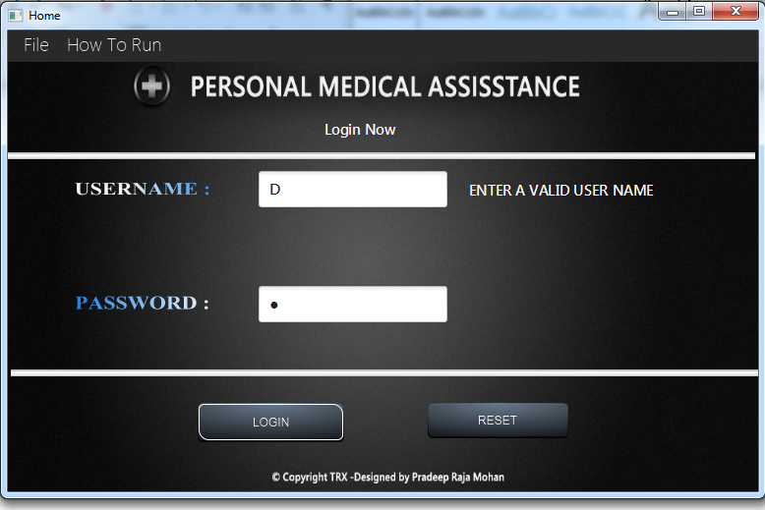

1. customer adding

